**CHAPTER 1**

**INTRODUCTION TO ONLINE VOTING SYSTEM**

**1.1 Introduction**

“ONLINE VOTING SYSTEM” is an online voting technique. In this system people who have citizenship of Kenya and whose age is above 18 years of age and any sex can give his\her vote online without going to any physical polling station. There is a database which is maintained in which all the names of voters with complete information is stored.

In “ONLINE VOTING SYSTEM” a voter can use his\her voting right online without any difficulty. He\She has to be registered first for him/her to vote. Registration is mainly done by the system administrator for security reasons. The system Administrator registers the voters on a special site of the system visited by him only by simply filling a registration form to register voter. Citizens seeking registration are expected to contact the system administrator to submit their details. After the validity of them being citizens of India has been confirmed by the system administrator by comparing their details submitted with those in existing databases such as those as the Registrar of Persons, the citizen is then registered as a voter.

After registration, the voter is assigned a secret Voter ID with which he/she can use to log into the system and enjoy services provided by the system such as voting. If invalid/wrong details are submitted, then the citizen is not registered to vote.

**1.2 Reasons for the project**

**To reduce man power**

To able to vote from home and reduce the number of man power also reduce the time.

**1.3 Problem Statement**

Now a days offline voting system would be a complex task to handle by election commission. Sometimes it may get riot. Some times the number of voter in the queue wold be more. This leads to waste of time.

**1.4 Aims & Objectives**

To provide a facility to make vote from home. To reduce time and riots.

**1.5 Scope**

It is focused on studying the existing system of voting in Kenya and to make sure that the peoples vote is counts, for fairness in the elective positions. This is also will produce:

* Less effort and less labor intensive, as the primary cost and focus primary on creating, managing, and running a secure web voting portal.
* Increasing number of voters as individuals will find it easier and more convenient to vote, especially those abroad.

:

.

**CHAPTER 2**

**REQUIREMENT ANALYSIS**

**2.1 Functional Requirements**

1. Registration of the voter is done by ELECTION COMMISION OF INDIA.
2. ELECTION COMMISION OF INDIA can change the information any time if required.
3. Registration of the Voter depends upon the information filled by the user.
4. Voter is given a unique ID and PASSWORD.
5. In the DATABASE information of every voter is stored.
6. Database shows the information of every user.

**2.2 HARDWARE REQUIREMENTS:**

* **Microsoft Windows XP Professional SP3/Vista SP1/Windows 7 Professional:**
  + **Processor:**800MHz Intel Pentium III or equivalent
  + **Memory:**512 MB
  + **Disk space:**750 MB of free disk space

**CHAPTER 3**

**SOFTWARE REQUIREMENT SPECIFICAIONS**

1. **MYSQL server-** It allows combination, extraction, manipulation and organization of data in the voters’ database. It is platform independent and therefore can be implemented and used across several such as Windows, Linux server and is compatible with various hardware mainframes. It is fast in performance, stable and provides business value at a low cost.
2. **Sublime editor-** The sublime IDE is an award-winning integrated development environment available for Windows, Mac, Linux, and Solaris. The sublime project consists of an open-source IDE and an application platform that enable developers to rapidly create web, enterprise, desktop, and mobile applications using the Java platform, as well as PHP, JavaScript and Ajax, Groovy and Grails, and C/C++.

The sublime project is supported by a vibrant developer community and offers extensive documentation and training resources as well as a diverse selection of third-party plugins.

1. **JAVASCRIPT coding-**This is for advanced user who find PHP codes easy to work with.
2. **Testing-** is done via WAMPSERVER.
3. **Web browsers**: Mozilla Firefox, Google chrome, Opera and Internet Explorer
4. **Reporting Tool** i.e. through Data Report.

**CHAPTER 4**

**ANALYSIS AND DESIGN**

**4.1 System Analysis**

The Online voting system (OVS) also known as e-voting is a term encompassing several different types of voting embracing both electronic means of counting votes. Electronic voting technology can include punched cards, optical scan voting systems and specialized voting kiosks (including self contained direct-recording electronic voting systems or DRE). It can also involve transmission of ballots and votes via telephones, private computer networks, or the internet.

Online voting is an electronic way of choosing leaders via a web driven application. The advantage of online voting over the common “queue method” is that the voters have the choice of voting at their own free time and there is reduced congestion. It also minimizes on errors of vote counting. The individual votes are submitted in a database which can be queried to find out who of the aspirants for a given post has the highest number of votes.

This system is geared towards increasing the voting percentage in Kenya since it has been noted that with the old voting method {the Queue System}, the voter turnout has been a wanting case. With system in place also, if high security is applied, cases of false votes shall be reduced.

With the “ONLINE VOTING SYSTEM”, a voter can use his\her voting right online without any difficulty. He\She has to register as a voter first before being authorized to vote. The registration should be done prior to the voting date to enable data update in the database.

However, not just anybody can vote. For one to participate in the elections, he/she must have the requirements. For instance, he/she must be a registered citizen i.e. must be 18 and above years old. As already stated, the project ‘Online Voting' provides means for fast and convenient voting and access to this system is limited only to registered voters.

Internet voting systems are appealing for several reasons which include; People are getting more used to work with computers to do all sorts of things, namely sensitive operations such as shopping and home banking and they allow people to vote far from where they usually live, helping to reduce absenteeism rate.

The main purposes of OVS include:

* Provision of improved voting services to the voters through fast, timely and convenient voting.
* Reduction of the costs incurred by the Kenyan Electoral Commission during voting time in paying the very many clerks employed for the sake of the success of the manual system.
* Check to ensure that the members who are registered are the only ones to vote. Cases of “Dead People” voting are also minimized.
* Online voting system (OVS) will require being very precise or cost cutting to produce an effective election management system.
* Therefore crucial points that this (OVS) emphasizes on are listed below.

1. Require less number of staff during the election.
2. This system is a lot easier to independently moderate the elections and subsequently reinforce its transparency and fairness.
3. Less capital, less effort, and less labor intensive, as the primary cost and effort will focus primarily on creating, managing, and running a secure online portal.
4. Increased number of voters as individual will find it easier and more convenient to vote, especially those abroad.

4.2 **Objectives Of The PROJECT**

The specific objectives of the project include:

* Reviewing the existing/current voting process or approach in Kenya;
* Coming up with an automated voting system in Kenya;
* Implementing a an automated/online voting system;
* Validating the system to ensure that only legible voters are allowed to vote.

**CHAPTER 5**

**IMPLEMENTATION**

The project is implemented on WAMP server. WAMP refers to windows, apache server, MYSQL, and PHP.

**5.1 PHP (PHP: Hypertext Pre-processor)**

It is a [server-side scripting](https://en.wikipedia.org/wiki/server-side_scripting) language designed for use in web based applications. As it is a server side scripting language, its use requires a web server installed, configured and enabled with PHP. The server used here is Apache Server.

When PHP parses a file (web servers are generally configured to have PHP parse files with the .php extension), it looks for an opening tag and a closing tag and then interprets the code between the two.

Example:

<?php

echo ‘HELLO WORLD”

?>

PHP will output everything that is not contained within an opening tag (commonly <?php, but could also be <? or <script language="PHP">, however the shorter <? tag is no longer recommended as it conflicts with XML opening tags) and a closing tag (?> or </script>) exactly as it is written. All statements in PHP should end with a semicolon; most of the time only one statement will occur on each line. This denotes to the PHP interpreter that the statement it has read is complete and that it should anticipate the next (or the ?> tag or EOF, end of file). This is because different text editors handle new lines differently.

Variables are locations in memory where information is stored. PHP scripts can contain variables, which are denoted with the $ at the start of their unique identifier. Unlike many low end languages, variables in PHP need not be declared and defined—when a variable is used, PHP automatically creates it and assigns it a null value if it does not already exist

**5.2 CSS (Cascading Style Sheet)**

 It is a [style sheet language](https://en.wikipedia.org/wiki/Style_sheet_language) used for describing the [presentation](https://en.wikipedia.org/wiki/Presentation_semantics) of a document written in a [mark-up language](https://en.wikipedia.org/wiki/Markup_language) like [HTML](https://en.wikipedia.org/wiki/HTML). CSS is a cornerstone technology of the [World Wide Web](https://en.wikipedia.org/wiki/World_Wide_Web), alongside HTML and [JavaScript](https://en.wikipedia.org/wiki/JavaScript).

CSS is designed to enable the separation of presentation and content, including [layout](https://en.wikipedia.org/wiki/Page_layout), [colours](https://en.wikipedia.org/wiki/Color), and [fonts](https://en.wikipedia.org/wiki/Typeface). This separation can improve content [accessibility](https://en.wikipedia.org/wiki/Accessibility), provide more flexibility and control in the specification of presentation characteristics, enable multiple [web pages](https://en.wikipedia.org/wiki/Web_page) to share formatting by specifying the relevant CSS in a separate .css file, and reduce complexity and repetition in the structural content.

Separation of formatting and content also makes it feasible to present the same mark-up page in different styles for different rendering methods, such as on-screen, in print, by voice (via speech-based browser or [screen reader](https://en.wikipedia.org/wiki/Screen_reader)), and on [Braille-based](https://en.wikipedia.org/wiki/Braille_display) tactile devices. CSS also has rules for alternate formatting if the content is accessed on a [mobile device](https://en.wikipedia.org/wiki/Mobile_device).

The name cascading comes from the specified priority scheme to determine which style rule applies if more than one rule matches a particular element. This cascading priority scheme is predictable. CSS has a simple [syntax](https://en.wikipedia.org/wiki/Syntax) and uses a number of English keywords to specify the names of various style properties. A style sheet consists of a list of rules. Each rule or rule-set consists of one or more selectors, and a declaration block.

**5.3 JavaScript**

JavaScript often abbreviated as JS, is a [high-level](https://en.wikipedia.org/wiki/High-level_programming_language), [interpreted](https://en.wikipedia.org/wiki/Interpreted_language) [programming language](https://en.wikipedia.org/wiki/Programming_language). It is a language which is also characterized as [dynamic](https://en.wikipedia.org/wiki/Dynamic_programming_language), [weakly typed](https://en.wikipedia.org/wiki/Weak_typing), [prototype-based](https://en.wikipedia.org/wiki/Prototype-based_programming) and [multi-paradigm](https://en.wikipedia.org/wiki/Multi-paradigm_programming_language).

Alongside [HTML](https://en.wikipedia.org/wiki/HTML) and [CSS](https://en.wikipedia.org/wiki/CSS), JavaScript is one of the three core technologies of the [World Wide Web](https://en.wikipedia.org/wiki/World_Wide_Web). JavaScript enables interactive [web pages](https://en.wikipedia.org/wiki/Web_page) and thus is an essential part of [web applications](https://en.wikipedia.org/wiki/Web_application). The vast majority of [websites](https://en.wikipedia.org/wiki/Website) use it, and all major [web browsers](https://en.wikipedia.org/wiki/Web_browser) have a dedicated [JavaScript engine](https://en.wikipedia.org/wiki/JavaScript_engine) to execute it.

As a multi-paradigm JavaScript supports [event-driven](https://en.wikipedia.org/wiki/Event-driven_programming), [functional](https://en.wikipedia.org/wiki/Functional_programming), and [imperative](https://en.wikipedia.org/wiki/Imperative_programming) (including [object-oriented](https://en.wikipedia.org/wiki/Object-oriented_programming) and [prototype-based](https://en.wikipedia.org/wiki/Prototype-based_programming)) [programming styles](https://en.wikipedia.org/wiki/Programming_paradigm). It has an [API](https://en.wikipedia.org/wiki/Application_programming_interface) for working with text, [arrays](https://en.wikipedia.org/wiki/Array_data_type), dates, [regular expressions](https://en.wikipedia.org/wiki/Regular_expression), and basic manipulation of the [DOM](https://en.wikipedia.org/wiki/Document_Object_Model), but the language itself does not include any [I/O](https://en.wikipedia.org/wiki/Input/output), such as networking, storage, or graphics facilities, relying for these upon the host environment in which it is embedded.

Initially only implemented [client-side](https://en.wikipedia.org/wiki/Client-side) in web browsers, JavaScript engines are now embedded in many other types of host software, including [server-side](https://en.wikipedia.org/wiki/Server-side) in web servers and databases, and in non-web programs such as word processors and [PDF](https://en.wikipedia.org/wiki/Portable_Document_Format) software, and in runtime environments that make JavaScript available for writing mobile and desktop applications, including desktop widgets.

**5.4 Bootstrap**

It is a [free and open-source](https://en.wikipedia.org/wiki/Free_and_open-source_software) front-end [framework](https://en.wikipedia.org/wiki/Application_framework) for designing [websites](https://en.wikipedia.org/wiki/Website) and [web applications](https://en.wikipedia.org/wiki/Web_application). It contains [HTML](https://en.wikipedia.org/wiki/HTML)- and [CSS](https://en.wikipedia.org/wiki/CSS)-based design templates for [typography](https://en.wikipedia.org/wiki/Typography), forms, buttons, navigation and other interface components, as well as optional JavaScript extensions. Unlike many earlier web frameworks, it concerns itself with [front-end development](https://en.wikipedia.org/wiki/Front-end_web_development) only.

Bootstrap is modular and consists of a series of [Less](https://en.wikipedia.org/wiki/Less_(stylesheet_language)) ([Sass](https://en.wikipedia.org/wiki/Sass_(stylesheet_language)) version 4 and onward) stylesheets that implement the various components of the toolkit. These stylesheets are generally compiled into a bundle and included in web pages, but individual components can be included or removed. Bootstrap provides a number of configuration variables that control things such as colour and padding of various components.

Since Bootstrap 2, the Bootstrap documentation has included a customization wizard which generates a customized version of Bootstrap based on the requested components and various settings. As of Bootstrap 4, [Sass](https://en.wikipedia.org/wiki/Sass_(stylesheet_language)) is used instead of [less](https://en.wikipedia.org/wiki/Less_(stylesheet_language)) for the stylesheets. Each Bootstrap component consists of an HTML structure, CSS declarations, and in some cases accompanying JavaScript code.

Grid system and responsive design comes standard with an 1170-pixel-wide [grid layout](https://en.wikipedia.org/wiki/CSS_Grid_Layout). Alternatively, the developer can use a variable-width layout. For both cases, the toolkit has four variations to make use of different resolutions and types of devices: mobile phones, portrait and landscape, tablets and PCs with low and high resolution. Each variation adjusts the width of the columns. The BLOCK DIAGRAM of our project database is as follows:

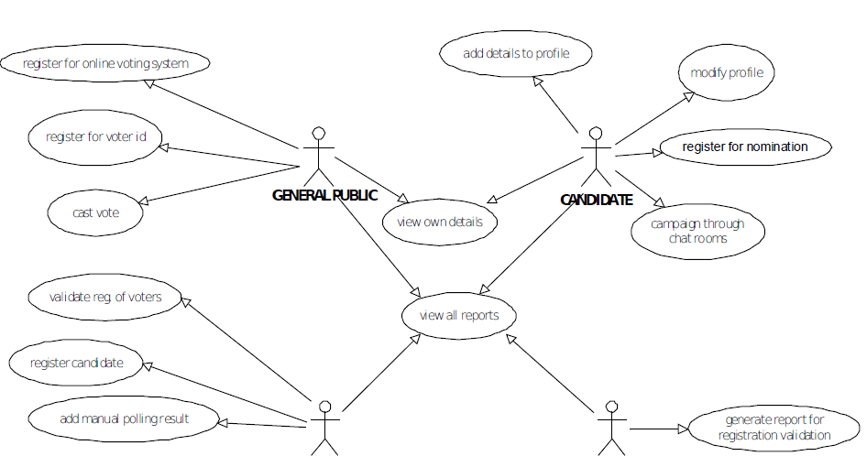

**Figure 5.5: BLOCK DIAGRAM**

**5.6 Data Flow Diagram**

A data flow diagram (DFD) maps out the flow of information for any process or system. It uses defined symbols like rectangles, circles and arrows, plus short text labels, to show data inputs, outputs, storage points and the routes between each destination.

Data Flow Diagram (DFD) provides a visual representation of the flow of information (i.e. data) within a system. By drawing a Data Flow Diagram, you can tell the information provided by and delivered to someone who takes part in system processes, the information needed in order to complete the processes and the information needed to be stored and accessed.

Candidates

Voter

Registered Voter

Database

Registered Candidate

ADMIN

Add Candidates

Add Voters

Update Voter Details

Check Results

Update Candidate

Details

Delete Candidate

**Figure 5.6.1: BLOCK DIAGRAM**

**CHAPTER 6**

**TESTING**

**6.1 Introduction to testing**

Software testing is an investigation conducted to provide stakeholders with information about the [quality](https://en.wikipedia.org/wiki/Quality_(philosophy)) of the [software](https://en.wikipedia.org/wiki/Software) product or service under test. Software testing can also provide an objective, independent view of the software to allow the business to appreciate and understand the risks of software implementation. Test techniques include the process of executing a program or application with the intent of finding [software bugs](https://en.wikipedia.org/wiki/Software_bug) (errors or other defects), and verifying that the software product is fit for use.

**6.2 Stages in the implementation of Testing**

## Unit Testing

During this first round of testing, the program is submitted to assessments that focus on specific units or components of the software to determine whether each one is fully functional. The main aim of this endeavor is to determine whether the application functions as designed. In this phase, **a unit can refer to a function, individual program or even a procedure**, and a [White-box Testing](http://stackoverflow.com/questions/402161/black-box-vs-white-box-testing) method is usually used to get the job done. One of the biggest benefits of this testing phase is that it can be run every time a piece of code is changed, allowing issues to be resolved as quickly as possible. It’s quite common for software developers to perform unit tests before delivering software to testers for formal testing.

## Integration Testing

Integration testing allows individuals the opportunity to combine all of the units within a program and test them as a group. This testing level is designed to **find interface defects between the modules/functions**. This is particularly beneficial because it determines how efficiently the units are running together. Keep in mind that no matter how efficiently each unit is running, if they aren’t properly integrated, it will affect the functionality of the software program. In order to run these types of tests, individuals can make use of various testing methods, but the specific method that will be used to get the job done will depend greatly on the way in which the units are defined.

## System Testing

System testing is the first level in which **the complete application is tested as a whole**. The goal at this level is to evaluate whether the system has complied with all of the outlined requirements and to see that it meets Quality Standards. System testing is undertaken by independent testers who haven’t played a role in developing the program. This testing is performed in an environment that closely mirrors production. System Testing is very important because it verifies that the application meets the technical, functional, and business requirements that were set by the customer.

## Acceptance Testing

The final level, Acceptance testing (or User Acceptance Testing), is conducted to **determine whether the system is ready for release**. During the Software development life cycle, requirements changes can sometimes be misinterpreted in a fashion that does not meet the intended needs of the users. During this final phase, the user will test the system to find out whether the application meets their business’ needs. Once this process has been completed and the software has passed, the program will then be delivered to production.

**6.3 Results**

Several errors were detected and rectified and the whole project is working as it should with proper output and high efficiency. The several tests performed are as follows:

|  |  |  |  |  |  |  |
| --- | --- | --- | --- | --- | --- | --- |
| **Test case id** | **Test case** | **Input data** | **Steps to execute the test case** | **Expected Result** | **Actual Result** | **Pass/Fail** |
| 1 | User Login screen. | Wrong username or password. | After entering the data click the “login”  Button. | A proper message indicating the error should appear and the user should be redirected to login screen. | A message  Was displayed saying incorrect username or password. | Pass |
| 2 | Admin login. | Wrong username or password. | After entering the data click the “login”  Button. | A proper message indicating the error should appear and the user should be redirected to login screen. | A message  was displayed saying incorrect username or password | Pass |
| 3 | Admin page. | Trying to add a candidate if has not. | Enter the candidate details and click on add. | A message should be displayed saying you already have a candidate | A message was displayed saying you already have a candidate. | Pass |
| 4 | Voter page. | Trying to add an voter into the list. | Add into voter details into db | The list should be updated. | The list is getting updated. | Pass |

**Chapter 7**

**SNAPSHOTS**

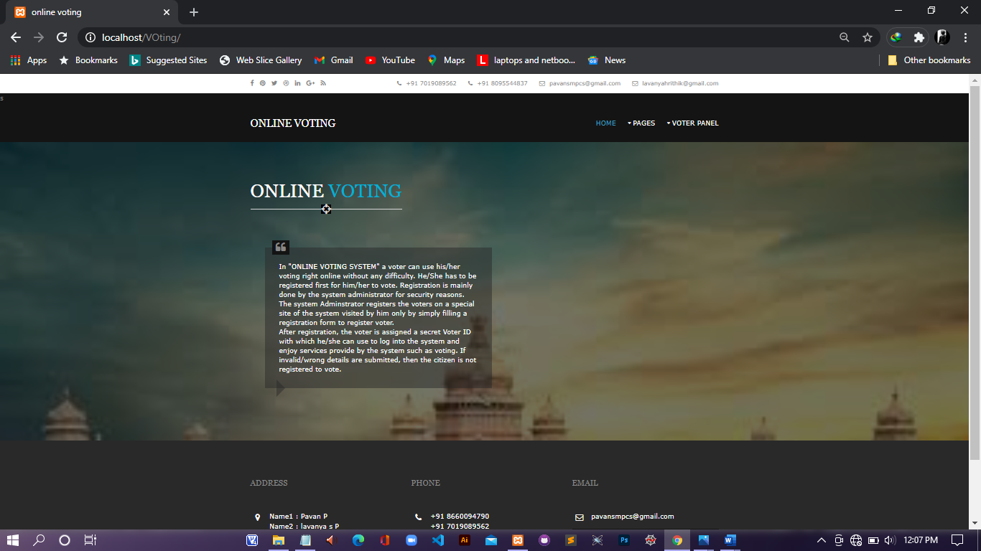

**Figure 7.1: Home page**

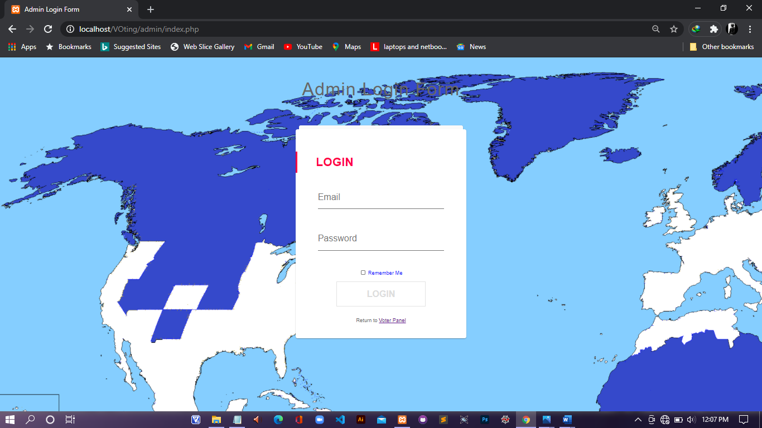

**Figure 7.2: Admin login page**

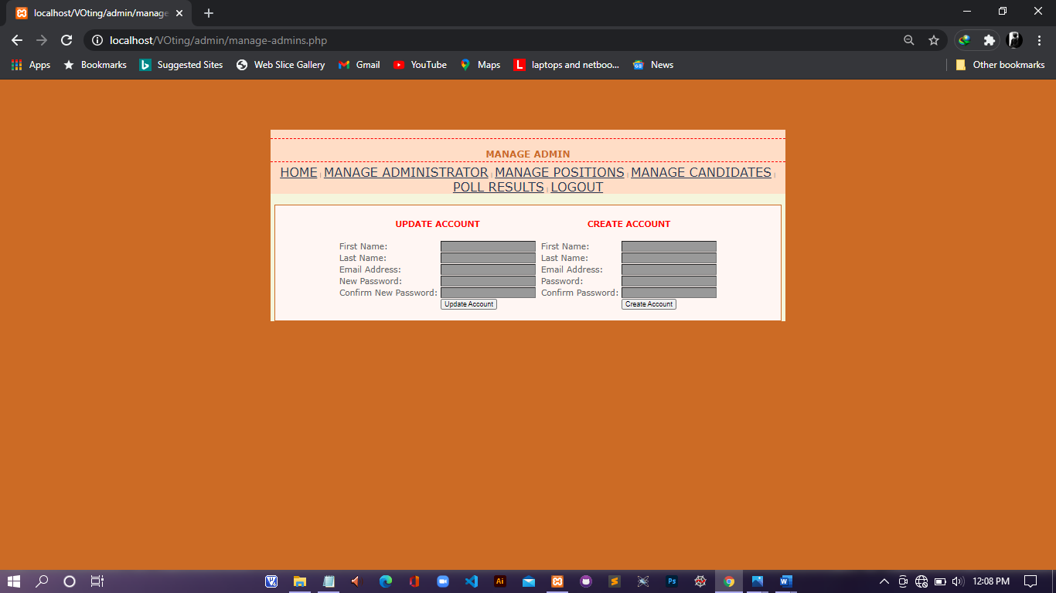

**Figure 7.3: admin manage page**

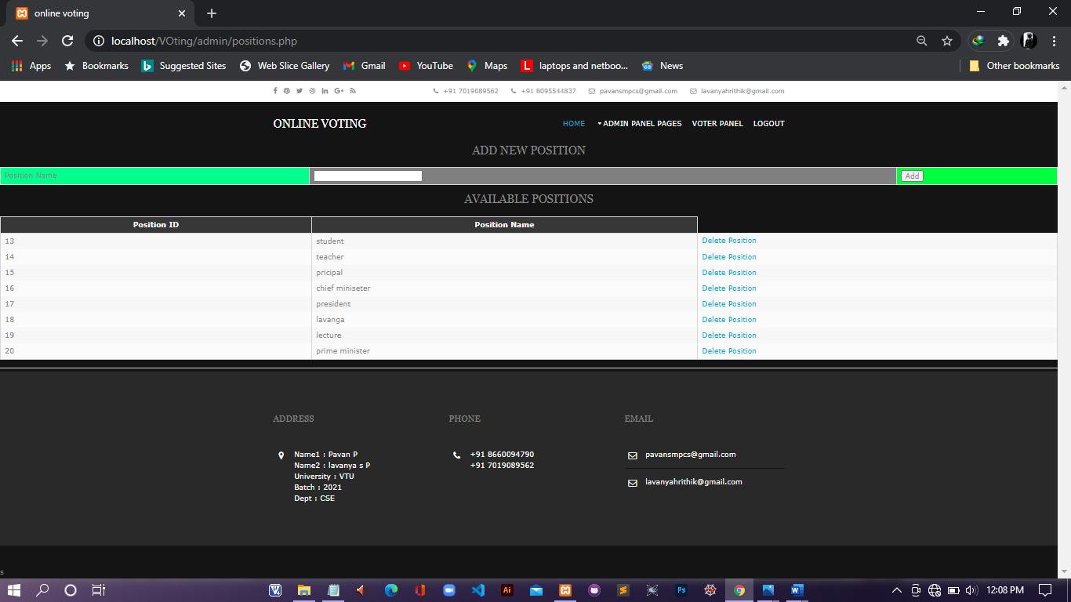

**Figure 7.4: candidate position page**

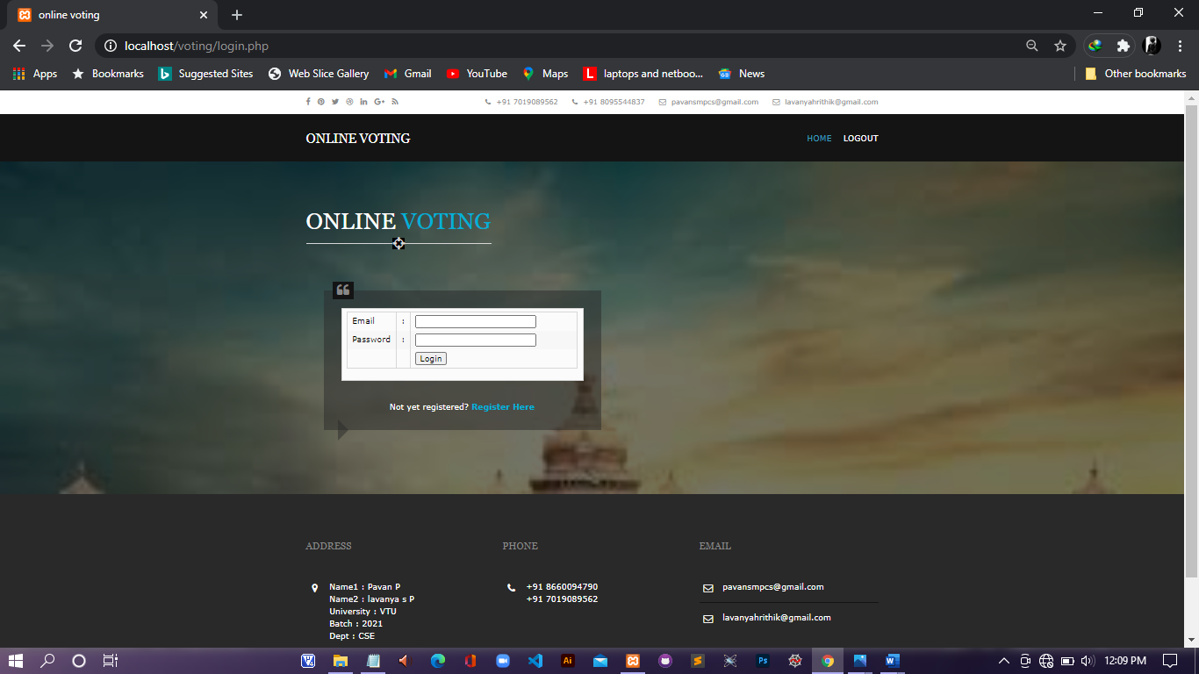

**Figure 7.5: voter login page**

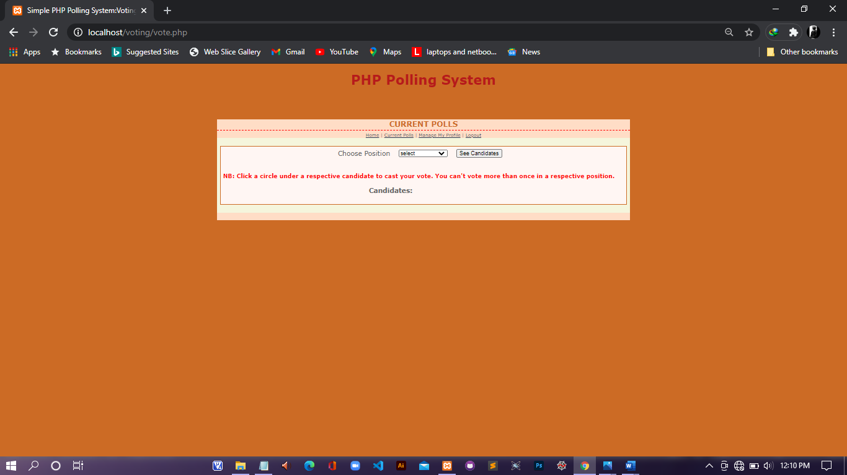

**Figure 7.6: polling page**

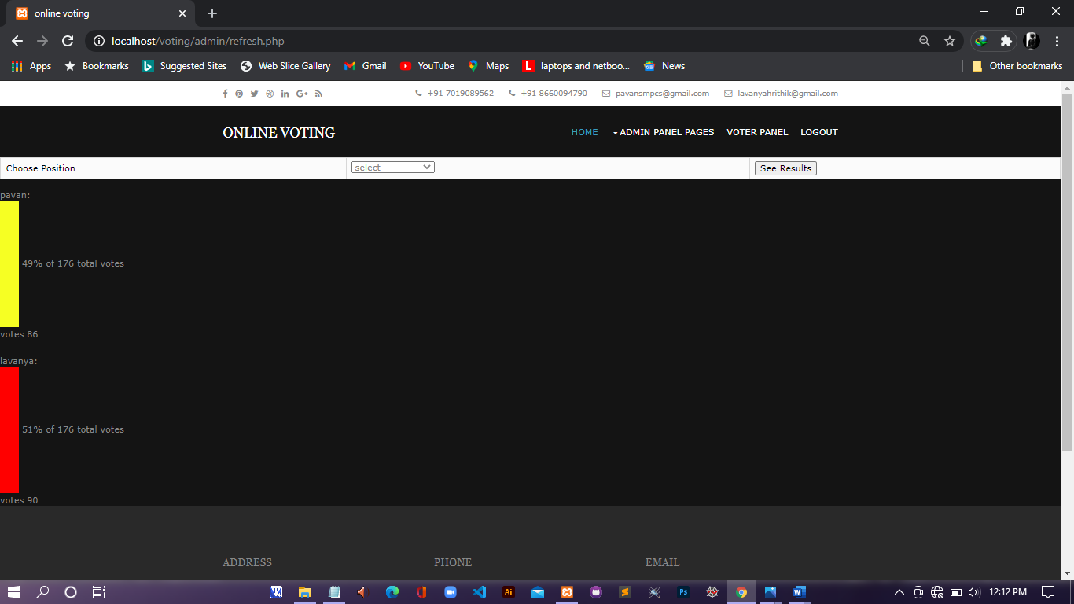

**Figure 7.7: election result page**

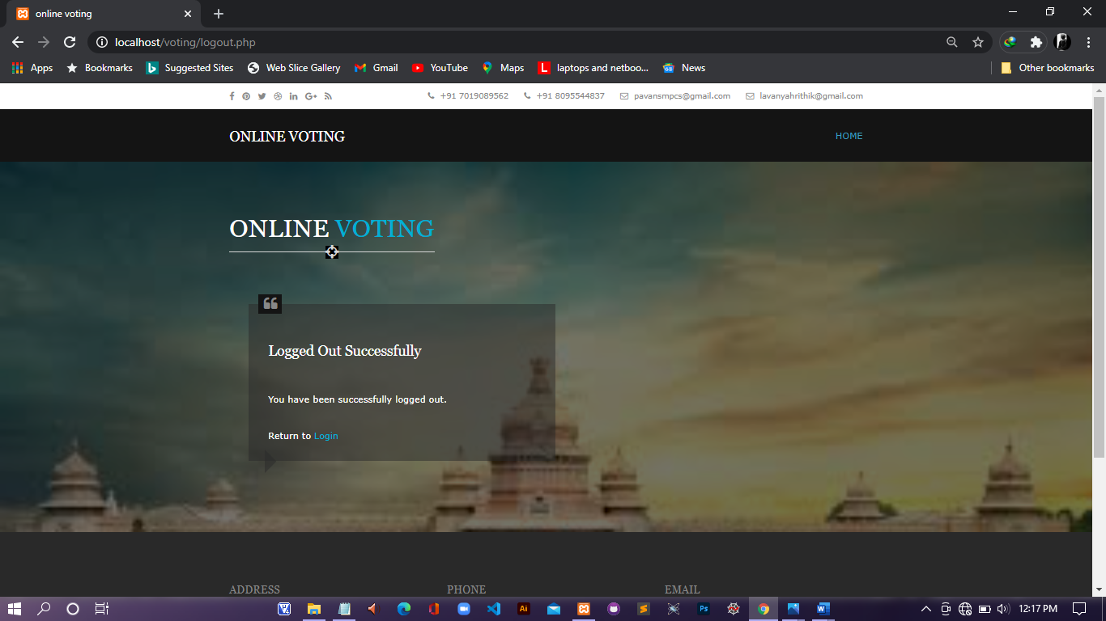

**Figure 7.8: logout page**

**CONCLUSION AND FUTURE ENHANCEMENT**

**CONCLUSION**

This Online Voting system will manage the Voter’s information by which voter can login and use his voting rights. The system will incorporate all features of Voting system. It provides the tools for maintaining voter’s vote to every party and it count total no. of votes of every party. There is a DATABASE which is maintained by the ELECTION COMMISION OF INDIA in which all the names of voter with complete information is stored.

In this user who is above 18 year’s register his/her information on the database and when he/she want to vote he/she has to login by his id and password and can vote to any party only single time. Voting detail store in database and the result is displayed by calculation. By online voting system percentage of voting is increases. It decreases the cost and time of voting process. It is very easy to use and It is vary less time consuming. It is very easy to debug.

**FUTURE ENHANCEMENT**

The future enhancements that can be made include:

* Can vote from home.
* Reduction of mans power.

**BIBLIOGRAPHY**

Books:

* Randy Connolly, Ricardo Hoar, **"Fundamentals of Web Development”,** 1stEdition.
* Robin Nixon, **“Learning PHP, MySQL &JavaScript with jQuery, CSS and**

**HTML5”,** 4thEdition, O’Reilly Publications, 2015.

Websites:

* [www.wikipedia.com](http://www.wikipedia.com)
* [www.stackoverflow.com](http://www.stackoverflow.com)